**13 January 2023**

**ASX Announcement**

**Gold Hydrogen to Commence Trading on ASX**

**Highlights:**

* **Gold Hydrogen Limited (GHY) lists on the Australian Securities Exchange (ASX) today.**
* **The Initial Public Offering raised gross proceeds of $20m, via a fully underwritten and oversubscribed offer.**
* **An airborne gravity-magnetic survey is scheduled to commence in March; the permit application was lodged on 22 December 2022 with the South Australian Department for Energy and Mining.**
* **2D seismic reprocessing completed in December 2022 has significantly improved subsurface architecture and identified additional leads outside existing prospects.**

The Directors of Gold Hydrogen Limited **(ASX: GHY) (the Company)** wish to advise that the Company has been admitted to the official list of the ASX with the quotation of the Company’s securities to commence at 11:00am AEDT on 13 January 2023.

The Company successfully raised gross proceeds of $20m via the issue of 40 million fully paid ordinary shares at an issue price of 50 cents each. The oversubscribed IPO raising was fully underwritten by Morgans Corporate Limited.

Gold Hydrogen is chaired by the Right Honourable Alexander Downer, who was the sitting member for the federal seat of Mayo in South Australia from 1984 to 2008. The seat of Mayo is within the Company’s granted and application tenure footprint.

Commenting on the Company’s ASX debut, Mr Downer said: *‘’To know we have the support of so many people in the hunt for low carbon energy sources, and that the search starts in my own state, is incredibly humbling. This is an Australian first, and very exciting for South Australia and Australia.*

*We need real solutions to decarbonize in ways that keep the lights on, and innovators like Gold Hydrogen will be essential to those goals.’’*

**About Gold Hydrogen**

Gold Hydrogen is focused on the discovery and development of world class natural hydrogen gas in a potentially extensive natural hydrogen province in South Australia. This region has only recently had its natural hydrogen potential identified by Gold Hydrogen. The domestic and global demand for hydrogen, combined with new natural hydrogen exploration techniques and experienced personnel, provides Gold Hydrogen with an extraordinary opportunity to define and ultimately develop a new natural hydrogen gas province.

The combined natural hydrogen permit area of the Gold Hydrogen group is approximately 75,332km2. Gold Hydrogen holds one granted petroleum exploration license (PEL 687) and its two 100% owned subsidiary companies (White Hydrogen Australia and Byrock Resources) hold an additional seven (7) applications for natural hydrogen exploration within South Australia (**refer Figure 1**).

Gold Hydrogen is also the preferred applicant for four (4) gas storage exploration licenses applications (GSELA) covering an additional 8,107km2 within the renewable energy zone of PEL 687 of the Yorke Peninsula region of South Australia. A summary of the status of the group’s tenure is outlined in **Appendix A**.

The group’s permit areas are characterised by low population densities, cooperative stakeholders and aspects of the natural environment suited to the exploration and development of a future natural hydrogen gas province. Gold Hydrogen places considerable importance on close liaison with traditional owners and all other stakeholders, and this approach has led to the grant of its key tenement PEL 687 in South Australia. The Company intends to continue to invest in these efforts.

**Figure 1 – Gold Hydrogen Group tenement and areas under application located in South Australia.**

*Airborne Survey*

In South Australia, Gold Hydrogen has commenced operations and submitted an 18,200-line km airborne gravity-magnetic survey to the Department of Energy and Mines for approval. This non-invasive airborne survey is scheduled to commence in early March 2023 with Stage 1 over the Yorke Peninsula, and Stage 2 over Kangaroo Island yet to be scheduled. The survey is designed to enhance subsurface understanding of rich natural hydrogen source rocks, structures, and identifying future well locations to mature the independently accessed Best Estimate Prospective Resources 1.3 billion kilograms of natural hydrogen gas in PEL 687 (refer prospective resource statement on following pages).

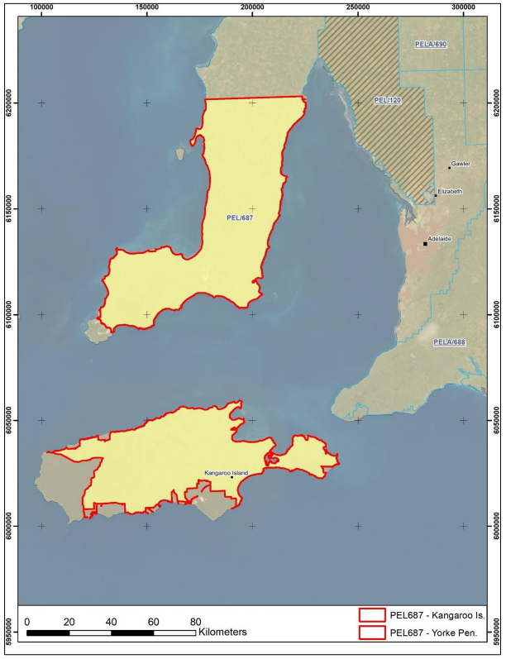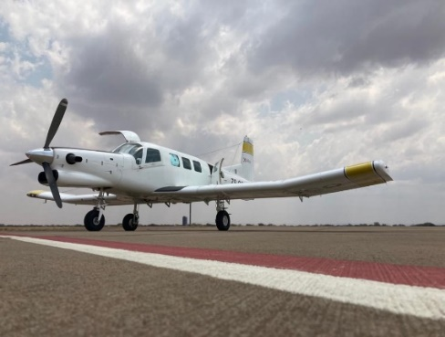

PEL 687



**Figure 2 – Ramsay Project airborne survey, PEL 687**

**Table 1 – Prospective Resource Statement for Natural Hydrogen**

|  |  |  |  |  |  |  |  |  |  |  |
| --- | --- | --- | --- | --- | --- | --- | --- | --- | --- | --- |
| **Gold Hydrogen’s Ramsay Project: Prospective Resources* of Hydrogen in ‘000 Tonnes – 30 September 2021** | | | | | | | | | | |
| **PEL** | **Prospects** | **SPE PRMS Sub-class** | **1U Low Estimate** | **2U Best Estimate** | **Mean** | **3U High Estimate** |  | **Pg** | **Pd** | **Pc** |
| **PEL 687** | **All Prospects and Leads** |  | **207** | **1313** | **4187** | **8820** |  | **22%** | **48%** | **10%** |
|  |  |  |  |  |  |  |  |  |  |  |
|  |  |  |  |  |  |  |  |  |  |  |
| Yorke Peninsula |  |  |  |  |  |  |  |  |  |  |
| PEL 687 | Ramsay FB | Prospect | 124 | 931 | 2712 | 6989 |  | 22% | 50% | 11% |
| PEL 687 | Ramsay Lst | Prospect | 10 | 70 | 191 | 492 |  | 26% | 50% | 13% |
| PEL 687 | Maitland | Lead | 7 | 26 | 40 | 92 |  | 17% | 35% | 6% |
|  |  |  |  |  |  |  |  |  |  |  |
| Kangaroo Island |  |  |  |  |  |  |  |  |  |  |
| PEL 687 | Navigator | Lead | 34 | 152 | 280 | 678 |  | 19% | 40% | 8% |
| PEL 687 | Kanmantoo | Prospect | 32 | 134 | 237 | 569 |  | 25% | 40% | 10% |

**\*This estimate of Natural Hydrogen Prospective Resources must be read in conjunction with the notes below, and it should be noted that the estimated quantities of Natural Hydrogen that may potentially be recovered by the application of a future development project(s) relate to undiscovered accumulations. These estimates have both an associated risk of discovery and a risk of development. Further exploration, appraisal and evaluation is required to determine the existence of a significant quantity of potentially recoverable Natural Hydrogen.**

Notes:

1. This reserves statement presents Gold Hydrogen’s Prospective Resources. Gold Hydrogen currently has no Reserves and no Contingent Resources.
2. Estimates are assessed to comply with the ASX Listing Rules for Prospective Resources and SPE-PRMS 2018 with the understanding that naturally occurring hydrogen may be considered a hydrocarbon since it has energy content and can be used stand alone and/or blended with sales gas. “U” implies Prospective Resources.
3. Per ASX Listing Rules 5.28.4 and 5.28.5 estimates are unrisked and aggregated arithmetically by category, hence caution that the aggregate low estimate may be a very conservative estimate and the aggregate high estimate may be a very optimistic estimate due to the portfolio effects of arithmetic summation.
4. Probabilistic methods are used to prepare the estimates. The distribution of the estimates is the “full distribution” and has not been truncated by application of the MEPS (minimum economic pool size concept).
5. The Reference Point is at the wellhead/edge of lease (i.e. wellhead facilities) so the estimates have no deduction for flare, vent or fuel consumed in operations.
6. Pg (Chance of Geologic Discovery), Pd (Chance of Development) and Pc (Chance of Commerciality = Pg x Pd) are calculated as a weight average of the P50’s of the H2 (‘000 Tonnes) of the prospects.
7. Pg incorporates Play Risk and Prospect Risk.
8. Pd incorporates an assessment across all SPE-PRMS Commerciality Criteria (i.e. not just economics).
9. Information in the table is rounded. Some totals in the tables may not add due to rounding.
10. Gold Hydrogen owns 100% of PEL 687 which has been issued under South Australian legislation.
11. This reserves statement:
    1. is based on, and fairly represents, information and supporting documentation prepared by the qualified petroleum reserves and resources evaluators listed in note 14 below. Details of each qualified petroleum reserves and resources evaluator’s employment and professional organisation membership are set out in note 14 below;
    2. has been approved by Luke Titus, who is a qualified petroleum reserves and resources evaluator and whose employment and professional organisation membership details are set out in note 14 of this reserves statement;
    3. is issued with the prior written consent of Luke Titus and Teof Rodrigues & Associates (“TRA” - involving Teof Rodrigues, Paul Strong, and Greg Horton, whose employment and professional organisation membership details are set out in note 14 of this reserves statement) as to the form and context in which the estimated Natural Hydrogen resources and the supporting information are presented.
12. There is no change to information or additional information, since the effective date of 30 September 2021, that Gold Hydrogen and TRA are aware of that would materially change the estimates in this reserves statement.
13. Gold Hydrogen engages independent experts TRA to evaluate reserves and resources.
14. Qualified Petroleum Reserves and Resources Evaluators are:

|  |  |  |
| --- | --- | --- |
| **Name** | **Employer** | **Professional organisation** |
| Luke Titus | Gold Hydrogen | SPE |
| Teof Rodrigues | Teof Rodrigues & Associates (TRA) | SPE, PESA |
| Paul Strong | Teof Rodrigues & Associates | GSL, AAPG, PESA |
| Greg Horton | Teof Rodrigues & Associates | SPE |

*2D Seismic Reprocessing – Yorke Peninsula*

Selected 2D seismic reprocessing completed in December 2022 has significantly improved subsurface architecture. Additional leads were identified outside previously mapped and reported prospects on the Yorke Peninsula. Ongoing works to finalise Stansbury Basin thickness, estimated Cambrian formation tops, faults, structures, basement depths, basement source rock type and local hydrology through mid-February 2023 will conclude potential new drill locations and well proposals.

**Figure 3 – Onshore Yorke Peninsula 2D seismic line. Notable horst and graben structure highlights extensional makeup of natural hydrogen basement source rocks. Some basement faults have been interpreted to extend into overlying Stansbury Basin Cambrian stratigraphic section and could be acting as migration pathways to potentially charged reservoirs.**

*Other Planned Activities*

Further non-invasive natural hydrogen gas soil surveys with national science agency CSIRO are scheduled to commence in March-April 2023. Up to 100 soil survey locations have been identified to explore areas associated with potential natural hydrogen surface seeps sometimes referred to as fairy circles. Additional workflows, including geological modelling with Schlumberger, further seismic interpretation with Total Seismic and core sampling of selected wells for natural hydrogen fluid inclusion lab analysis and rock mechanics experiments by CSIRO is ongoing and will enhance the Company’s understanding of additional areas of high natural hydrogen gas prospectivity.

Gold Hydrogen is initially focusing on natural hydrogen exploration in the Stansbury Basin, Kanmantoo Trough and Kanmantoo Platforms of South Australia. The Company is planning to twin where possible historic wells that have reported natural hydrogen occurrences. Exploration drilling is scheduled to commence in Q3 2023 with 3 exploration wells currently being planned. Well testing to determine reservoir performance is planned to follow drilling.

The Company intends to keep the market up to date on the results of these activities as well as all other progress towards expanding its granted tenement areas and defining its resources. Investors can expect regular updates in this regard.

**Figure 4 – Instantaneous measurement instrumentation. A. Hammer drill, B. GA5000 coupled with an inox tube. C. GA multi-gas analyser instantaneous readings, D. PHD-4 Portable Helium detector, detection at ppm level**

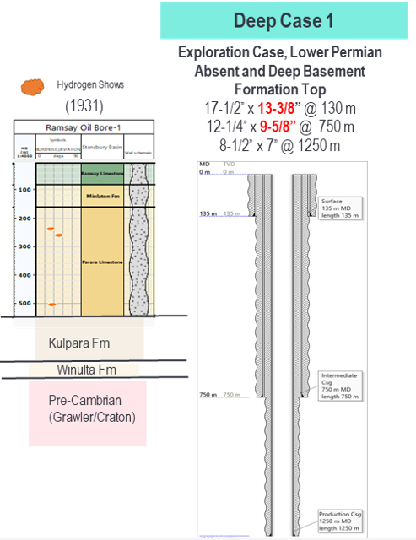

**Figure 5 – Type well for Yorke Peninsula natural hydrogen exploration well**

**Post-IPO Capital Structure**

The Company currently has 140 million fully paid ordinary shares (comprising 40 million fully paid shares issued under the IPO and 100 million shares on issue immediately prior to the IPO) and 3,900,000 unlisted options on issue.

Of the 100 million shares on issue immediately prior to the IPO, 97.2% will be under ASX-imposed or voluntary escrow arrangements until at least 13 July 2023, with 83.1% subject to escrow arrangements until 13 January 2025.

The unlisted options are all held by Board and Management and are escrowed for a period of 24 months. The conditions of vesting and exercise are as outlined in **Appendix B**.

Information regarding the Top 20 holdings and security distribution schedules per class, etc have been separately disclosed.

**Further Information**

Further information on the Gold Hydrogen group, its projects, and its Board and Management can be found on the Company’s website ([www.goldhydrogen.com.au](http://www.goldhydrogen.com.au)) together with a copy of the Company’s Replacement Prospectus of 29 November 2022.

Gold Hydrogen also has accounts on LinkedIn and Twitter ([@GHY_ASX](https://twitter.com/GHY_ASX)), and copies of market releases will be emailed to all interested parties who register via [info@goldhydrogen.com.au](mailto:info@goldhydrogen.com.au)

*** - *** - ***

The Board looks forward to providing regular updates to the market as preliminary exploration efforts commence on the Company’s flagship Ramsay Project.

This announcement has been authorised for release by the Board.

On behalf of the Board

Karl Schlobohm

Company Secretary

**For Company Enquiries Contact:**

Neil McDonald – Managing Director Karl Schlobohm – Company Secretary / CFO

[nmcdonald@goldhydrogen.com.au](mailto:nmcdonald@goldhydrogen.com.au) [kschlobohm@goldhydrogen.com.au](mailto:kschlobohm@goldhydrogen.com.au)

+61 7 3521 8038 +61 7 3521 8038

**For Media Enquiries Contact:**

Matthew Doman – Australian Public Affairs

[mdoman@apa.au](mailto:mdoman@apa.au)

+61 421 888 858

**Forward Looking Statement / Future Performance**

This announcement may contain certain forward-looking statements and opinion Forward-looking statements, including projections, forecasts and estimates, are provided as a general guide only and should not be relied on as an indication or guarantee of future performance and involve known and unknown risks, uncertainties, assumptions, contingencies and other important factors, many of which are outside the control of the Company and which are subject to change without notice and could cause the actual results, performance or achievements of the Company to be materially different from the future results, performance or achievements expressed or implied by such statements. Past performance is not necessarily a guide to future performance and no representation or warranty is made as to the likelihood of achievement or reasonableness of any forward-looking statements or other forecast. Nothing contained in this announcement, nor any information made available to you is, or and shall be relied upon as, a promise, representation, warranty or guarantee as to the past, present or the future performance of Gold Hydrogen Limited.

**Appendix A**

**Overview of the Gold Hydrogen Group’s PEL, PELAs and GSELAs**

**Appendix B**

### Summary of Director and Manager Options

|  |  |  |  |  |  |
| --- | --- | --- | --- | --- | --- |
| **Option holder** | **Options** | **Performance Milestone** | **Exercise Price** | **Vesting date** | **Expiry** |
| Alexander Downer (or a related company, trust or associate) | 300,000 | The Market Value for one Share reaching 150% of the IPO Price | 150% of IPO Price  (75 cents) | 1.5 years after date of admission to ASX | 3 years after date of admission to ASX |
| 300,000 | The Market Value for one Share reaching 200% of the IPO Price | 200% of IPO Price  ($1.00) | 2 years after date of admission to ASX | 4 years after date of admission to ASX |
| 300,000 | The Market Value for one Share reaching 350% of the IPO Price | 350% of IPO Price  ($1.75) | 3 years after date of admission to ASX | 4 years after date of admission to ASX |
| Each of Neil McDonald, Luke Titus, Roger Cressey, Katherine Barnet and Karl Schlobohm (or, in each case, a related company, trust or associate) | 200,000 | The Market Value for one Share reaching 150% of the IPO Price | 150% of IPO Price  (75 cents) | 1.5 years after date of admission to ASX | 3 years after date of admission to ASX |
| 200,000 | The Market Value for one Share reaching 200% of the IPO Price | 200% of IPO Price  ($1.00) | 2 years after date of admission to ASX | 4 years after date of admission to ASX |
| 200,000 | The Market Value for one Share reaching 350% of the IPO Price | 350% of IPO Price  ($1.75) | 3 years after date of admission to ASX | 4 years after date of admission to ASX |